Property Analysis BI Developer Competition Tasks – Part 1

# **Part 1**

# Transform data from multiple data sources, ensure the accuracy and integrity of relevant data sets

**Solution Approach:**

* Do manual simple corrections to the cell values that are catchable to plain sight
* Define staging database structure and warehouse database structure
* Load excel/csv files in to a staging database country-wise
  + Develop SSIS packages to automate the data cleansing and enriching to each country dataset
  + Populate default data for each dimension table on the warehouse database.
  + Load cleansed and enriched data into staging tables of each country
  + Map, combined, transform data from each staging table into standardised warehouse database table.

1. Populate default data for each dimension table on the datawarehouse database(To avoid NULL in the Foreign keys of the Fact Tables)

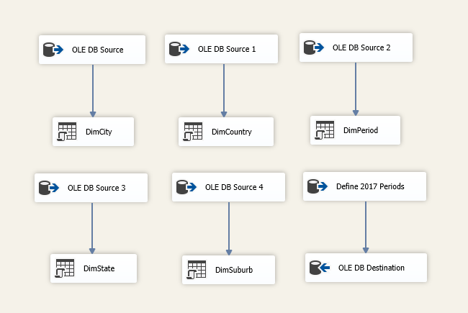

1. Australia Geographical Areas

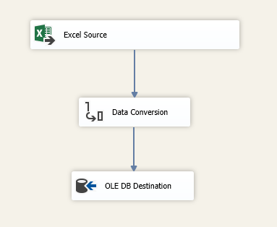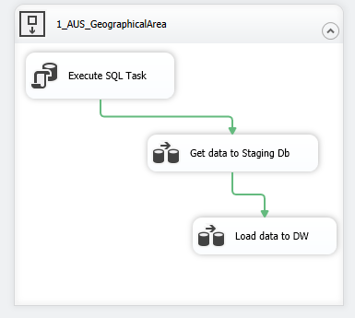

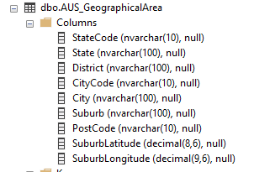

<Staging Table>

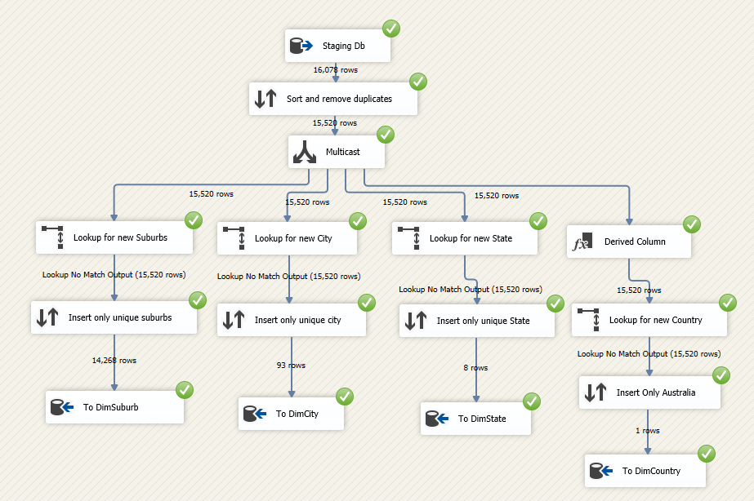

1. 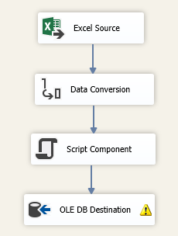Australia Transport

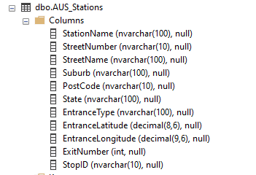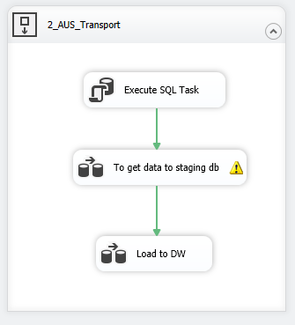

<Staging Table>

// Script to retrieve address breakdown from Google Maps API by using latitude and longitude values

try

{

HttpResponseMessage response = client.GetAsync($"https://maps.googleapis.com/maps/api/geocode/json?latlng={Row.Latitude.Trim()},{Row.Longitude.Trim()}&key=xxxxx").Result;

if (response.IsSuccessStatusCode)

{

var jsonString = response.Content.ReadAsStringAsync().Result;

Rootobject rootObject = JsonConvert.DeserializeObject<Rootobject>(jsonString);

var result = rootObject.results[1];

if (result != null)

{

Row.StreetNumber = result.address_components.Where(c => c.types.Contains("street_number")).FirstOrDefault()?.short_name;

Row.StreetName = result.address_components.Where(c => c.types.Contains("route")).FirstOrDefault()?.long_name;

Row.Suburb = result.address_components.Where(c => c.types.Contains("locality")).FirstOrDefault()?.long_name;

Row.PostCode = result.address_components.Where(c => c.types.Contains("postal_code")).FirstOrDefault()?.long_name;

Row.State = result.address_components.Where(c => c.types.Contains("administrative_area_level_1")).FirstOrDefault()?.long_name;

Row.Country = result.address_components.Where(c => c.types.Contains("country")).FirstOrDefault()?.long_name;

}

}

}

catch (Exception ex)

{

// TODO :; Find how to write into error output

}

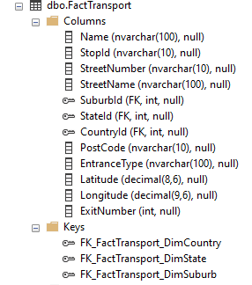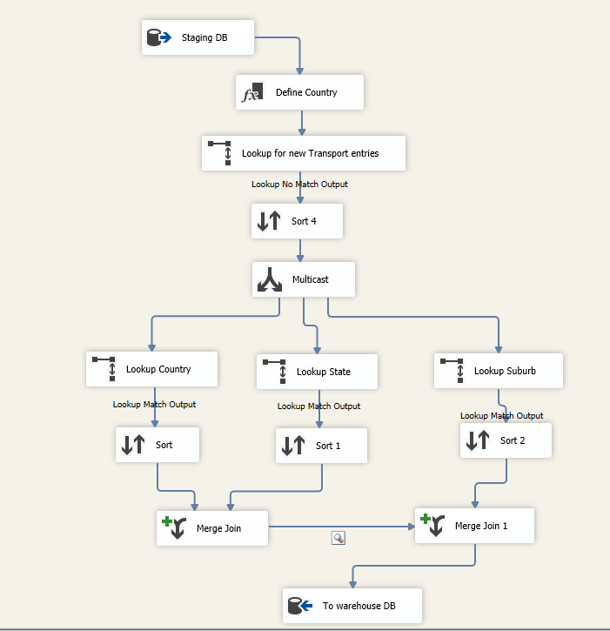

< Fact Transport Table>

1. 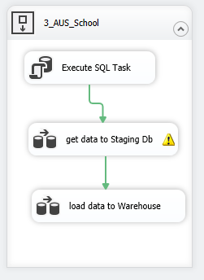Australia Schools (Loading Data to School Fact Table)

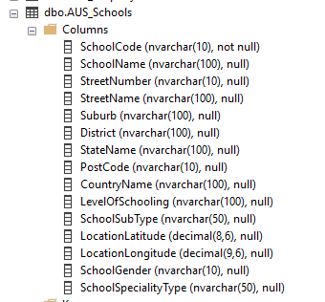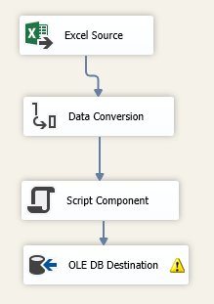

<Staging Table>

1. sdaf

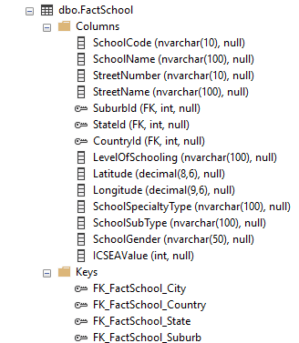

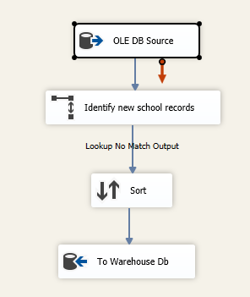

<Fact School Table>

1. Australia Property Median (Loading to DW and Fact Table)

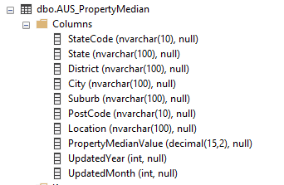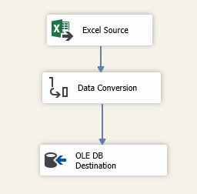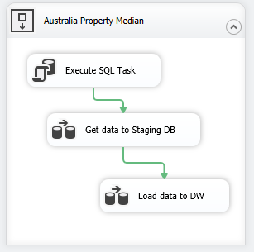

<Staging Table>

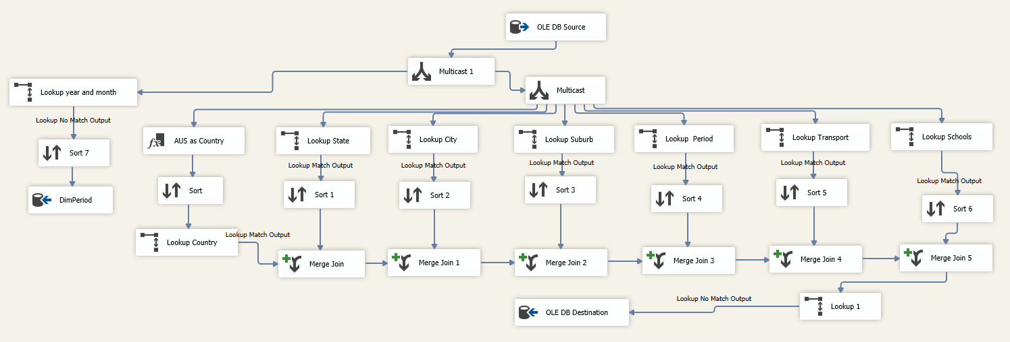

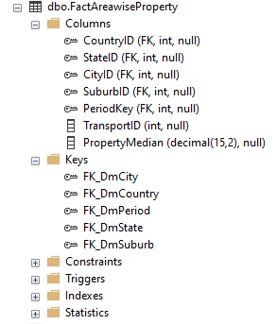

**Fact Table** - FactAreawiseProperty

# Design, build and test of a data warehouse solution.

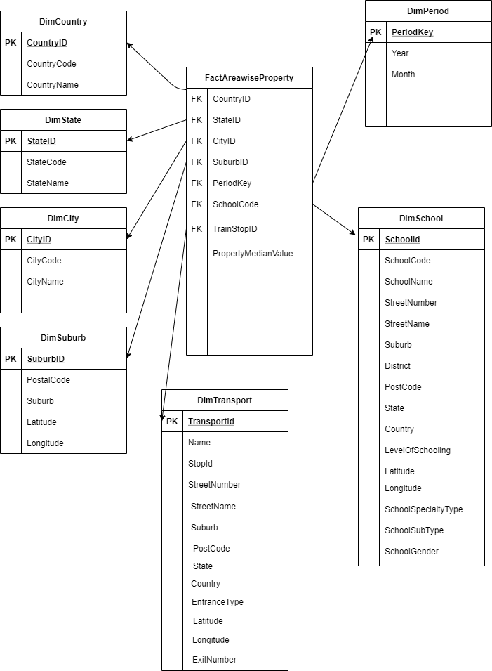

# Generate and submit a copy of SQL script (*.txt or *.sql) after database and tables are created in your SQL Server.

USE [master]

GO

/****** Object: Database [Task1_Warehouse] Script Date: 23/12/2020 9:43:39 AM ******/

CREATE DATABASE [Task1_Warehouse]

CONTAINMENT = NONE

ON PRIMARY

( NAME = N'Task1_Warehouse', FILENAME = N'C:\Program Files\Microsoft SQL Server\MSSQL14.MSSQLSERVER\MSSQL\DATA\Task1_Warehouse.mdf' , SIZE = 73728KB , MAXSIZE = UNLIMITED, FILEGROWTH = 65536KB )

LOG ON

( NAME = N'Task1_Warehouse_log', FILENAME = N'C:\Program Files\Microsoft SQL Server\MSSQL14.MSSQLSERVER\MSSQL\DATA\Task1_Warehouse_log.ldf' , SIZE = 73728KB , MAXSIZE = 2048GB , FILEGROWTH = 65536KB )

GO

ALTER DATABASE [Task1_Warehouse] SET COMPATIBILITY_LEVEL = 140

GO

IF (1 = FULLTEXTSERVICEPROPERTY('IsFullTextInstalled'))

begin

EXEC [Task1_Warehouse].[dbo].[sp_fulltext_database] @action = 'enable'

end

GO

ALTER DATABASE [Task1_Warehouse] SET ANSI_NULL_DEFAULT OFF

GO

ALTER DATABASE [Task1_Warehouse] SET ANSI_NULLS OFF

GO

ALTER DATABASE [Task1_Warehouse] SET ANSI_PADDING OFF

GO

ALTER DATABASE [Task1_Warehouse] SET ANSI_WARNINGS OFF

GO

ALTER DATABASE [Task1_Warehouse] SET ARITHABORT OFF

GO

ALTER DATABASE [Task1_Warehouse] SET AUTO_CLOSE OFF

GO

ALTER DATABASE [Task1_Warehouse] SET AUTO_SHRINK OFF

GO

ALTER DATABASE [Task1_Warehouse] SET AUTO_UPDATE_STATISTICS ON

GO

ALTER DATABASE [Task1_Warehouse] SET CURSOR_CLOSE_ON_COMMIT OFF

GO

ALTER DATABASE [Task1_Warehouse] SET CURSOR_DEFAULT GLOBAL

GO

ALTER DATABASE [Task1_Warehouse] SET CONCAT_NULL_YIELDS_NULL OFF

GO

ALTER DATABASE [Task1_Warehouse] SET NUMERIC_ROUNDABORT OFF

GO

ALTER DATABASE [Task1_Warehouse] SET QUOTED_IDENTIFIER OFF

GO

ALTER DATABASE [Task1_Warehouse] SET RECURSIVE_TRIGGERS OFF

GO

ALTER DATABASE [Task1_Warehouse] SET DISABLE_BROKER

GO

ALTER DATABASE [Task1_Warehouse] SET AUTO_UPDATE_STATISTICS_ASYNC OFF

GO

ALTER DATABASE [Task1_Warehouse] SET DATE_CORRELATION_OPTIMIZATION OFF

GO

ALTER DATABASE [Task1_Warehouse] SET TRUSTWORTHY OFF

GO

ALTER DATABASE [Task1_Warehouse] SET ALLOW_SNAPSHOT_ISOLATION OFF

GO

ALTER DATABASE [Task1_Warehouse] SET PARAMETERIZATION SIMPLE

GO

ALTER DATABASE [Task1_Warehouse] SET READ_COMMITTED_SNAPSHOT OFF

GO

ALTER DATABASE [Task1_Warehouse] SET HONOR_BROKER_PRIORITY OFF

GO

ALTER DATABASE [Task1_Warehouse] SET RECOVERY FULL

GO

ALTER DATABASE [Task1_Warehouse] SET MULTI_USER

GO

ALTER DATABASE [Task1_Warehouse] SET PAGE_VERIFY CHECKSUM

GO

ALTER DATABASE [Task1_Warehouse] SET DB_CHAINING OFF

GO

ALTER DATABASE [Task1_Warehouse] SET FILESTREAM( NON_TRANSACTED_ACCESS = OFF )

GO

ALTER DATABASE [Task1_Warehouse] SET TARGET_RECOVERY_TIME = 60 SECONDS

GO

ALTER DATABASE [Task1_Warehouse] SET DELAYED_DURABILITY = DISABLED

GO

EXEC sys.sp_db_vardecimal_storage_format N'Task1_Warehouse', N'ON'

GO

ALTER DATABASE [Task1_Warehouse] SET QUERY_STORE = OFF

GO

USE [Task1_Warehouse]

GO

/****** Object: Table [dbo].[DimCity] Script Date: 23/12/2020 9:43:39 AM ******/

SET ANSI_NULLS ON

GO

SET QUOTED_IDENTIFIER ON

GO

CREATE TABLE [dbo].[DimCity](

[CityId] [int] IDENTITY(1,1) NOT NULL,

[CityCode] [nvarchar](10) NULL,

[City] [nvarchar](100) NULL,

CONSTRAINT [PK_Dim_City] PRIMARY KEY CLUSTERED

(

[CityId] ASC

)WITH (PAD_INDEX = OFF, STATISTICS_NORECOMPUTE = OFF, IGNORE_DUP_KEY = OFF, ALLOW_ROW_LOCKS = ON, ALLOW_PAGE_LOCKS = ON) ON [PRIMARY]

) ON [PRIMARY]

GO

/****** Object: Table [dbo].[DimCountry] Script Date: 23/12/2020 9:43:39 AM ******/

SET ANSI_NULLS ON

GO

SET QUOTED_IDENTIFIER ON

GO

CREATE TABLE [dbo].[DimCountry](

[CountryID] [int] IDENTITY(1,1) NOT NULL,

[CountryCode] [nvarchar](10) NULL,

[CountryName] [nvarchar](100) NULL,

CONSTRAINT [PK_DimCountry] PRIMARY KEY CLUSTERED

(

[CountryID] ASC

)WITH (PAD_INDEX = OFF, STATISTICS_NORECOMPUTE = OFF, IGNORE_DUP_KEY = OFF, ALLOW_ROW_LOCKS = ON, ALLOW_PAGE_LOCKS = ON) ON [PRIMARY]

) ON [PRIMARY]

GO

/****** Object: Table [dbo].[DimPeriod] Script Date: 23/12/2020 9:43:39 AM ******/

SET ANSI_NULLS ON

GO

SET QUOTED_IDENTIFIER ON

GO

CREATE TABLE [dbo].[DimPeriod](

[PeriodKey] [int] IDENTITY(1,1) NOT NULL,

[Year] [int] NULL,

[Month] [int] NULL,

CONSTRAINT [PK_DimPeriod] PRIMARY KEY CLUSTERED

(

[PeriodKey] ASC

)WITH (PAD_INDEX = OFF, STATISTICS_NORECOMPUTE = OFF, IGNORE_DUP_KEY = OFF, ALLOW_ROW_LOCKS = ON, ALLOW_PAGE_LOCKS = ON) ON [PRIMARY]

) ON [PRIMARY]

GO

/****** Object: Table [dbo].[DimSchool] Script Date: 23/12/2020 9:43:39 AM ******/

SET ANSI_NULLS ON

GO

SET QUOTED_IDENTIFIER ON

GO

CREATE TABLE [dbo].[DimSchool](

[SchoolId] [int] IDENTITY(1,1) NOT NULL,

[SchoolCode] [nvarchar](10) NULL,

[SchoolName] [nvarchar](100) NULL,

[StreetNumber] [nvarchar](10) NULL,

[StreetName] [nvarchar](100) NULL,

[Suburb] [nvarchar](100) NULL,

[District] [nvarchar](100) NULL,

[PostCode] [nvarchar](10) NULL,

[State] [nvarchar](100) NULL,

[Country] [nvarchar](100) NULL,

[LevelOfSchooling] [nvarchar](100) NULL,

[Latitude] [decimal](8, 6) NULL,

[Longitude] [decimal](9, 6) NULL,

[SchoolSpecialtyType] [nvarchar](100) NULL,

[SchoolSubType] [nvarchar](100) NULL,

[SchoolGender] [nvarchar](50) NULL,

CONSTRAINT [PK_DimSchool] PRIMARY KEY CLUSTERED

(

[SchoolId] ASC

)WITH (PAD_INDEX = OFF, STATISTICS_NORECOMPUTE = OFF, IGNORE_DUP_KEY = OFF, ALLOW_ROW_LOCKS = ON, ALLOW_PAGE_LOCKS = ON) ON [PRIMARY]

) ON [PRIMARY]

GO

/****** Object: Table [dbo].[DimState] Script Date: 23/12/2020 9:43:39 AM ******/

SET ANSI_NULLS ON

GO

SET QUOTED_IDENTIFIER ON

GO

CREATE TABLE [dbo].[DimState](

[StateId] [int] IDENTITY(1,1) NOT NULL,

[StateCode] [nvarchar](10) NULL,

[StateName] [nvarchar](100) NULL,

CONSTRAINT [PK_Dim_State] PRIMARY KEY CLUSTERED

(

[StateId] ASC

)WITH (PAD_INDEX = OFF, STATISTICS_NORECOMPUTE = OFF, IGNORE_DUP_KEY = OFF, ALLOW_ROW_LOCKS = ON, ALLOW_PAGE_LOCKS = ON) ON [PRIMARY]

) ON [PRIMARY]

GO

/****** Object: Table [dbo].[DimSuburb] Script Date: 23/12/2020 9:43:39 AM ******/

SET ANSI_NULLS ON

GO

SET QUOTED_IDENTIFIER ON

GO

CREATE TABLE [dbo].[DimSuburb](

[SuburbId] [int] IDENTITY(1,1) NOT NULL,

[PostalCode] [nvarchar](10) NULL,

[Suburb] [nvarchar](100) NULL,

[Latitude] [decimal](8, 6) NULL,

[Longitude] [decimal](9, 6) NULL,

CONSTRAINT [PK_Dim_Suburb] PRIMARY KEY CLUSTERED

(

[SuburbId] ASC

)WITH (PAD_INDEX = OFF, STATISTICS_NORECOMPUTE = OFF, IGNORE_DUP_KEY = OFF, ALLOW_ROW_LOCKS = ON, ALLOW_PAGE_LOCKS = ON) ON [PRIMARY]

) ON [PRIMARY]

GO

/****** Object: Table [dbo].[DimTransport] Script Date: 23/12/2020 9:43:39 AM ******/

SET ANSI_NULLS ON

GO

SET QUOTED_IDENTIFIER ON

GO

CREATE TABLE [dbo].[DimTransport](

[TransportId] [int] IDENTITY(1,1) NOT NULL,

[Name] [nvarchar](100) NULL,

[StopId] [nvarchar](10) NULL,

[StreetNumber] [nvarchar](10) NULL,

[StreetName] [nvarchar](100) NULL,

[Suburb] [nvarchar](100) NULL,

[PostCode] [nvarchar](10) NULL,

[State] [nvarchar](100) NULL,

[Country] [nvarchar](100) NULL,

[EntranceType] [nvarchar](100) NULL,

[Latitude] [decimal](8, 6) NULL,

[Longitude] [decimal](9, 6) NULL,

[ExitNumber] [int] NULL,

CONSTRAINT [PK_DimTransport] PRIMARY KEY CLUSTERED

(

[TransportId] ASC

)WITH (PAD_INDEX = OFF, STATISTICS_NORECOMPUTE = OFF, IGNORE_DUP_KEY = OFF, ALLOW_ROW_LOCKS = ON, ALLOW_PAGE_LOCKS = ON) ON [PRIMARY]

) ON [PRIMARY]

GO

/****** Object: Table [dbo].[FactAreawiseProperty] Script Date: 23/12/2020 9:43:39 AM ******/

SET ANSI_NULLS ON

GO

SET QUOTED_IDENTIFIER ON

GO

CREATE TABLE [dbo].[FactAreawiseProperty](

[CountryID] [int] NULL,

[StateID] [int] NULL,

[CityID] [int] NULL,

[SuburbID] [int] NULL,

[PeriodKey] [int] NULL,

[SchoolID] [int] NULL,

[TransportID] [int] NULL,

[PropertyMedian] [decimal](15, 2) NULL

) ON [PRIMARY]

GO

ALTER TABLE [dbo].[FactAreawiseProperty] WITH CHECK ADD CONSTRAINT [FK_DmCity] FOREIGN KEY([CityID])

REFERENCES [dbo].[DimCity] ([CityId])

GO

ALTER TABLE [dbo].[FactAreawiseProperty] CHECK CONSTRAINT [FK_DmCity]

GO

ALTER TABLE [dbo].[FactAreawiseProperty] WITH CHECK ADD CONSTRAINT [FK_DmCountry] FOREIGN KEY([CountryID])

REFERENCES [dbo].[DimCountry] ([CountryID])

GO

ALTER TABLE [dbo].[FactAreawiseProperty] CHECK CONSTRAINT [FK_DmCountry]

GO

ALTER TABLE [dbo].[FactAreawiseProperty] WITH CHECK ADD CONSTRAINT [FK_DmState] FOREIGN KEY([StateID])

REFERENCES [dbo].[DimState] ([StateId])

GO

ALTER TABLE [dbo].[FactAreawiseProperty] CHECK CONSTRAINT [FK_DmState]

GO

ALTER TABLE [dbo].[FactAreawiseProperty] WITH CHECK ADD CONSTRAINT [FK_DmSuburb] FOREIGN KEY([SuburbID])

REFERENCES [dbo].[DimSuburb] ([SuburbId])

GO

ALTER TABLE [dbo].[FactAreawiseProperty] CHECK CONSTRAINT [FK_DmSuburb]

GO

ALTER TABLE [dbo].[FactAreawiseProperty] WITH CHECK ADD CONSTRAINT [FK_Period] FOREIGN KEY([PeriodKey])

REFERENCES [dbo].[DimPeriod] ([PeriodKey])

GO

ALTER TABLE [dbo].[FactAreawiseProperty] CHECK CONSTRAINT [FK_Period]

GO

ALTER TABLE [dbo].[FactAreawiseProperty] WITH CHECK ADD CONSTRAINT [FK_School] FOREIGN KEY([SchoolID])

REFERENCES [dbo].[DimSchool] ([SchoolId])

GO

ALTER TABLE [dbo].[FactAreawiseProperty] CHECK CONSTRAINT [FK_School]

GO

ALTER TABLE [dbo].[FactAreawiseProperty] WITH CHECK ADD CONSTRAINT [FK_Transport] FOREIGN KEY([TransportID])

REFERENCES [dbo].[DimTransport] ([TransportId])

GO

ALTER TABLE [dbo].[FactAreawiseProperty] CHECK CONSTRAINT [FK_Transport]

GO

USE [master]

GO

ALTER DATABASE [Task1_Warehouse] SET READ_WRITE

GO